Topic:- Introduction to Java

1. History and Evolution of Java:
- Java was developed by James Gosling at Sun Microsystems in 1995.
- It was designed to be simple, object-oriented, and platform-independent.
- Initially called Oak, it was later renamed to Java.
- Today, it’s widely used in web apps, Android apps, and enterprise software.

2. Features of Java:
- Object-Oriented Programming (OOP): Everything in Java revolves around objects and classes.
- Platform Independence: Java code runs on any system that has a JVM (Write Once, Run Anywhere).
- Security: Java runs programs inside a secure environment called the sandbox.
- Robust & Portable: It handles errors well and works across different devices and operating systems.

3. Java Program Structure and Compilation Process:
- A Java program must have a class and a main method (public static void main(String[] args)).
- Source code is written in a .java file.
- It is compiled by the Java Compiler (javac) into bytecode (.class).

4. Role of Bytecode and JVM:
- Bytecode is a set of platform-independent instructions.
- JVM (Java Virtual Machine) reads and executes bytecode.
- This makes Java both compiled and interpreted.

Topic:-Basic Java Concepts – Part 1

1. Java Syntax Overview:
- Every Java program must have a class.
- The file name should match the class name.
- Statements end with a semicolon ;.
- Code blocks are enclosed in { }.

2. Classes, Objects, and Methods:
- Class: A blueprint or template that defines properties and behavior.
- Object: An instance of a class.
- Method: A block of code that performs a specific task.

3. Main Method and Execution Flow:
- The main method is the entry point of any Java program:
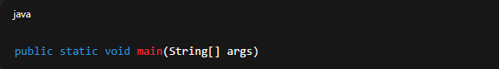
- Execution starts from the main method.

4. Printing and Debugging Basics:
- Use System.out.println() to print output on the console.
- Example:
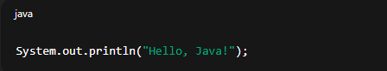
- Useful for checking values during debugging.

Topic:- Basic Java Concepts – Part 2

1. Packages and Imports:
- Package: A way to group related classes.
- Example: java.util is a package containing utility classes.
- Use import to include packages in your code.

2. Variables and Initialization:
- Variable: A container that stores data.
- Example:
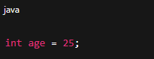
- Always initialize variables before using them.

3. Scope of Variables:
- Defines where the variable can be accessed.
  - Inside a method → local scope
  - Inside a class → instance or static scope
4. Java Naming Conventions:
- Class names → Start with uppercase (e.g., StudentData)
- Variable names → Start with lowercase (e.g., studentName)
- Constants → All uppercase (e.g., MAX_LIMIT)
- Improves readability and consistency.

Topic:- JDK, JRE & JVM
1. JDK (Java Development Kit):
- Contains tools needed to develop Java programs.
- Includes JRE, compiler (javac), and other utilities.
2. JRE (Java Runtime Environment):
- Provides an environment to run Java programs.
- Includes JVM and necessary libraries.
3. JVM (Java Virtual Machine):
- Executes Java bytecode.
- Handles memory management and garbage collection.

4. Execution Steps of a Java Program:
- Write code → Program.java
- Compile → javac Program.java → generates Program.class (bytecode)
- Run → java Program → JVM executes the bytecode

Topic: Java Naming Conventions & Eclipse IDE – Part 1
1. Java Naming Standards:
- Follow consistent naming for readability.
  - Class: EmployeeDetails
  - Method: calculateSalary()
  - Variable: employeeName
2. Installing & Setting up Eclipse IDE:
- Download Eclipse IDE from its official website.
- Install Java JDK first, then launch Eclipse.
- Select a workspace folder (this is where your projects are stored).
3. Creating and Running a Java Project:
- Go to File → New → Java Project.
- Add a class inside the project.
- Write your code and click Run ▶ to execute.
4. Workspace and Perspective:
- Workspace: Storage location for your projects.
- Perspective: View layout in Eclipse (e.g., Java, Debug).

Topic: Eclipse IDE – Part 2
1. Project Explorer, Console, and Debug Views:
- Project Explorer: Shows your files and classes.
- Console: Displays output or errors.
- Debug View: Used to check code line by line during debugging.
2. Writing, Running, and Debugging Java Programs:
- Write your code → Save → Click Run.
- Use Debug mode to pause and inspect program flow.
3. Breakpoints and Variable Inspection:
- Set a breakpoint by clicking next to a line number.
- When debugging, you can check variable values in the Variables tab.

4. Exporting and Importing Projects:
- To share or move a project:
  - Export: File → Export → Java → Runnable JAR file.
  - Import: File → Import → Existing Project into Workspace.

Topic: Comments, Identifiers & Keywords
1. Types of Comments:
- Single-line: // This is a comment
- Multi-line:
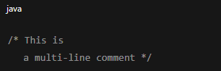
- Javadoc:
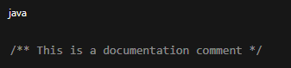

2. Identifiers:
- Names given to classes, variables, and methods.
- Must begin with a letter, $, or _.
- Cannot use Java keywords as identifiers.
3. Keywords:
- Predefined words with special meaning (e.g., class, public, static, int).
- All keywords are lowercase.
4. Importance of Readability:
- Clean code helps in understanding and maintaining projects easily.

Topic: Object Concept
1. Understanding Classes and Objects:
- Class: Template or blueprint.
- Object: Instance of a class created using new keyword.

2. Creating Objects and Accessing Members:
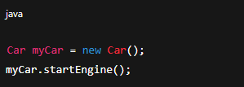

3. Constructor Basics:
- Special method used to initialize objects.
- Has the same name as the class.
- Example:
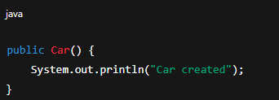

4. Object Lifecycle:
- Object is created → used → destroyed by Garbage Collector when no longer needed.

Topic: Local & Global Variables

1. Types of Variables:
- Local Variable: Declared inside methods; accessible only there.
- Instance Variable: Declared in class but outside methods; belongs to each object.
- Static Variable: Shared among all objects of the class.
2. Scope and Lifetime:
- Local variables exist till method execution ends.
- Instance variables exist as long as the object exists.
- Static variables exist for the entire program duration.
3. Shadowing:
- When local and instance variables have the same name, local variable hides the instance one.
4. Best Practices:
- Use meaningful names.
- Avoid global variables unless necessary.
- Initialize variables properly.

Topic: Data Types – Part 1
1. Primitive vs Non-Primitive Data Types:
- Primitive: Basic types like int, float, char, boolean.
- Non-Primitive: Objects like String, arrays, and classes.
2. Range and Size of Primitives:
Type | Size | Example
byte | 1 byte | -128 to 127
short | 2 bytes | -32,768 to 32,767
int | 4 bytes | -2 billion to +2 billion
long | 8 bytes | Very large numbers
float | 4 bytes | Decimal numbers
double | 8 bytes | More precise decimal numbers
char | 2 bytes | Single character (‘A’, ‘@’)
boolean | 1 bit | true or false
3. Type Casting:
- Implicit (Automatic): small → large type
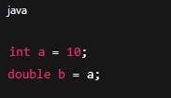
- Explicit (Manual): large → small type
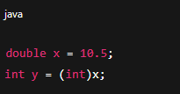

4. Wrapper Classes:
- Allow primitives to be used as objects.
- Examples: Integer, Double, Character, Boolean.
- Useful for collections like ArrayList.

Eclipse Screenshot:-
